What is the best way to space my retrieval sessions?
Encoding and retrieval
Encoding and retrieval are two sides of the learning coin.
You cannot be efficient and accurate without both encoding and retrieval. Outside of inadequate encoding, "retrieval failure" is a common cause of knowledge decay of previously encoded information.
When information is encoded to a higher quality, we need less retrieval.
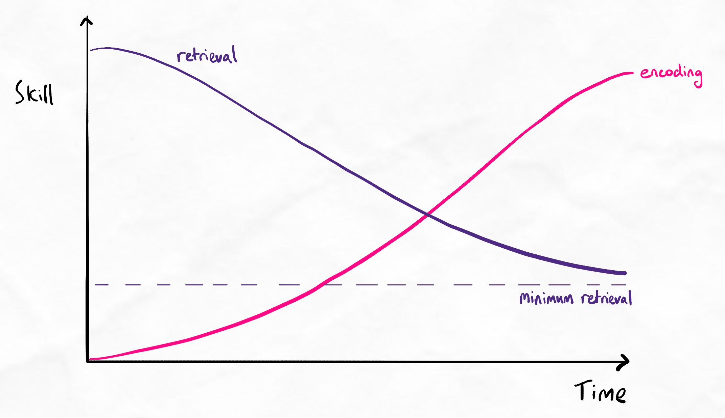
Graph showing the relationship between encoding and retrieval

Key principles
- As encoding gets better, we forget less and need to do less retrieval
- Encoding skill takes time to develop, during this time, retrieval is crucial to address knowledge decay
- We always need some level of retrieval because our brain is never leak-proof (i.e. there is always some knowledge decay)
Technically, encoding and retrieval are not completely separate processes. The majority opinion in learning science is that encoding and retrieval influence each other as fundamentally intertwined processes, rather than two distinct processes.
In our program, we discuss them separately because the physical actions and techniques used for optimising retrieval tend to be distinct from the methods used for first-pass encoding. From a practical perspective, keeping the two separate is more helpful.
Spacing schedules
As explained in the spacing lesson, it is not necessary to follow an ultra-strict spacing schedule.
We recommend using some form of semi-regular spacing that allows you to keep on top of your material.
General rule
We typically recommend a spacing schedule of same-day, 1 day, 1 week and 1 month. However, this can be followed very loosely.
Here is an example of this rule which would be perfectly acceptable if applied in practice:
Monday and Tuesday | Same-day retrieval: New material is learned and revised on the same day.
Wednesday | One-day retrieval: Interleaved retrieval session for Monday and Tuesday content (and Wednesday if new material was learned too)
Thursday | Same-day retrieval for new content: New material is learned and revised on the same day.
Friday or Saturday | One-week retrieval: Interleaved retrieval session for all content over the last 2 weeks.
End of the month | One-month retrieval: Interleaved retrieval session for the last 4 weeks.
3 to 4 weeks prior to assessment | One-month retrieval+: Retrieve everything relevant for the assessments
With the above schedule, we have a same-day revision, a mid-week revision, an end-of-week revision and an end-of-month revision. The end-of-week revision encompasses the last 2 weeks, and the end-of-month encompasses the last 4 weeks.
All material will be revised within 1 to 3 days of first learning it, then 1 to 2 weeks later, then 2 to 4 weeks later. When combined with prestudy and on-the-day studying, this means that any material is encoded and re-encoded (via interleaved retrieval practice) around 6 times in a given month.
A track record of success
This exact schedule is used by thousands of our students to great success.
Isn't this excessive and time-consuming?
A spacing schedule like the above can seem excessive for those with lower levels of encoding. This is because revising an entire month's worth of content might seem like a titanic task.
In reality, effective encoding techniques will mean that approximately 80 to 90% of the material is retained by the end-of-week revision, meaning that one week's material can be revised in just a few hours.
Because each subsequent interleaved retrieval session reduces the amount of knowledge decay and re-encodes information, the end-of-month revision for 4 weeks' worth of material might be a half-day activity.
Based on the systems we teach in our program, we are also likely to be prestudying and learning material in batches, ahead of formal class/lecture/course schedules. This means that we have concentrated bursts of studying, getting a month or more ahead of 'class', with spaced retrieval of just a few hours every week.
As such, the total time spent and ease of maintaining such a schedule is extremely easy.
Isn't this excessive and time-consuming?
What if my encoding skills are not good enough yet?
This kind of spacing schedule can be difficult for those with low encoding ability. However, because encoding and retrieval practice are both necessary for performance, deficiencies in encoding must be addressed through more retrieval. Over time, as encoding improves, you will naturally see the time taken for retrieval reduce.
In the short term, we recommend having a strict spaced interleaved retrieval schedule as a core foundation of your learning system.

